|  |  |  |  |  |  |  |  |  |  |  |  |  |  |  |  |  |  |  |  |  |
| --- | --- | --- | --- | --- | --- | --- | --- | --- | --- | --- | --- | --- | --- | --- | --- | --- | --- | --- | --- | --- |
| **VIETNAM NATIONAL UNIVERSITY – HOCHIMINH CITY**  **INTERNATIONAL UNIVERSITY**  **SCHOOL OF COMPUTER SCIENCE AND ENGINEERING**  Logo | Trường Đại học Quốc Tế - International University  **WEB APPLICATION DEVELOPMENT**  **IT093IU**  **FINAL REPORT**  **Topic: EGAY AUCTION SITE**  By Group: gambler99 – Members List   |  |  |  |  | | --- | --- | --- | --- | | **Number** | **Name** | **Student ID** | **Role** | | 1 | Đàm Nguyễn Trọng Lễ |  | Leader | | 2 | Nguyễn Quốc Trung |  | Member | | 3 | Lê Hưng | ITCSIU22271 | Member | | 4 | Lê Nhật Anh | ITCSIU22254 | Member |   Instructor: Assoc. Prof. Nguyen Van Sinh |

TABLE OF CONTENTS

I. INTRODUCTION 3

1. ABOUT US 3

2. THE PRODUCT’S INFORMATION 4

3. WORK BREAKDOWN STRUCTURE 4

4. DEVELOPMENT PROCESS: 7

5. DEVELOPMENT ENVIRONMENT: 7

# I. INTRODUCTION

This section presents background information about the software development team - Gambler 99. It also introduces the core concept and basic details of the “Egay Auction Site” project. In addition, the main constraints encountered during the development process are outlined.

## 1. ABOUT US

Gambler 99 is a team of four members formed as part of the Web Application Development course project. The primary objective is to design and implement a functional web application that demonstrates the practical application of web development concepts. This project also serves as valuable preparation for upcoming internships, allowing team members to gain hands-on experience with real-world tools, workflows, and problem-solving strategies. Throughout the development process, knowledge gained from lectures, textbooks, and online resources has been applied to build a platform that incorporates essential features of a modern website. The application supports dynamic user interaction, simulating the kind of technical and collaborative challenges commonly faced in professional software development environments.

Here is the information of team members and the tasks distribution:

|  |  |  |
| --- | --- | --- |
| **Name** | **Task** | **Contribution** |
| Đàm Nguyễn Trọng Lễ | Full - Stack | % |
| Nguyễn Quốc Trung | Front-end | % |
| Lê Hưng | Back-end | % |
| Lê Nhật Anh | Back-end | % |

Table 1. Task Distribution

## 2. THE PRODUCT’S INFORMATION

Inspired by the success and influence of eBay - a pioneer in online auctions and consumer-to-consumer (C2C) sales—we chose to build a web like it to gain a deeper understanding of the unique architecture and functionality behind real-time bidding systems. The auction feature, which sets eBay apart from traditional e-commerce platforms, introduces dynamic pricing, time-sensitive competition, and live user interaction making it both technically challenging and intellectually engaging to implement. Through this project, we are able to explore essential concepts such as real-time auction mechanics, bid synchronization, user authentication, product management, and secure transactions.

## 3. WORK BREAKDOWN STRUCTURE

The structure of this project can be expressed in the figure 1:

Figure 1. General structure of the project

This project contains three primary components: the Frontend, the Backend, and the Database. Each of these components is further organized into distinct substructures which describe the tasks needed to be accomplished of each teamembers. These diagrams below illustrate about the overview of the works of building database, backend and frontend. Each process of building them contains specification (identify all of things need to be constructed), implementation (implement, code base on the specification) and testing (check out the result of implementation whether meets the specification)

The Task for the Database Design can be expressed the the figure 2:

Figure 2. Database overview

* The tasks of the backend can be expressed in the figure 3:

Figure 3. Backend overview.

* The tasks of the Frontend can be expressed in the figure 4:

Figure 4. Frontend overview.

## 4. DEVELOPMENT PROCESS:

This project is built step by step from the basic feature to the more complex. Each feature was designed base on the “Sofware Development Life Circle” rule: planning, Define requirement, coding, testing. In the testing step, if is there any bugs, the process will go back to the coding. This approach provide a alige model for building the project, which employs incremental and iterative development that are also called sprints. The figure 5 below will visulize the Alige Model:

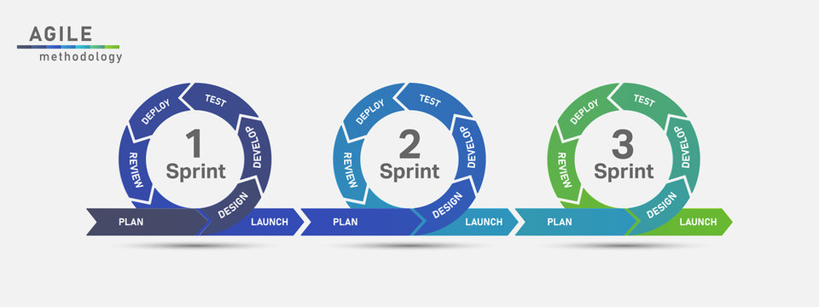

Figure 5. Alige Model.

## 5. DEVELOPMENT ENVIRONMENT:

The project is an e-commerce platform, which requires a user-friendly, responsive, and secure implementation to meet modern web standards and user expectations. To achieve this, appropriate technologies were carefully selected to support both functionality and maintainability.

**Programming Languages:**

* Java was chosen for backend development due to its robustness, strong community support, and seamless integration with enterprise-level frameworks.
* JavaScript was used for frontend development, enabling dynamic user interfaces and smooth interaction with backend services.
* MySQL: A relational database management system used to store and manage structured data. It supports SQL for querying data and integrates smoothly with Java through Spring Data JPA, allowing efficient database access and manipulation.

**Frameworks:**

* Spring Boot was used to develop the backend, following the MVC architecture. It simplifies the creation of RESTful APIs and integrates well with:
* Spring Security for handling authentication and authorization using JWT (JSON Web Tokens).
* Spring Data JPA for database interaction and ORM mapping.
* Uses application.properties for centralized, flexible configuration.
* ReactJS Framework was used for building the frontend, providing a component-based architecture and efficient rendering. React allows for a responsive user experience and facilitates seamless integration with REST APIs.

**Tools:**

* Docker was used for hosting mySQL server: By using configure docker-compose file, and initialized SQL queries, it can easily install and running the database server, especially using docker to make the configuration setting (connection name, password, port) is consistent within each team members machine. Furthremore, mySQL workbench is also selected as a IDE tool for seeing and editing database.
* Intelliji and Vscode are two main IDEs for coding frontend and backend because they are provide friendly UI and useful extensions, plugins for Java and Javascript (NodeJS).
* Postman was used to test all of the API services throughout the development process. It allowed the team to send HTTP requests (GET, POST, PUT, DELETE) to the backend, verify responses, debug issues, and ensure that each endpoint behaved as expected before connecting the frontend.

II.